Mantid
PM report to Project Management Board
3rd April 2020
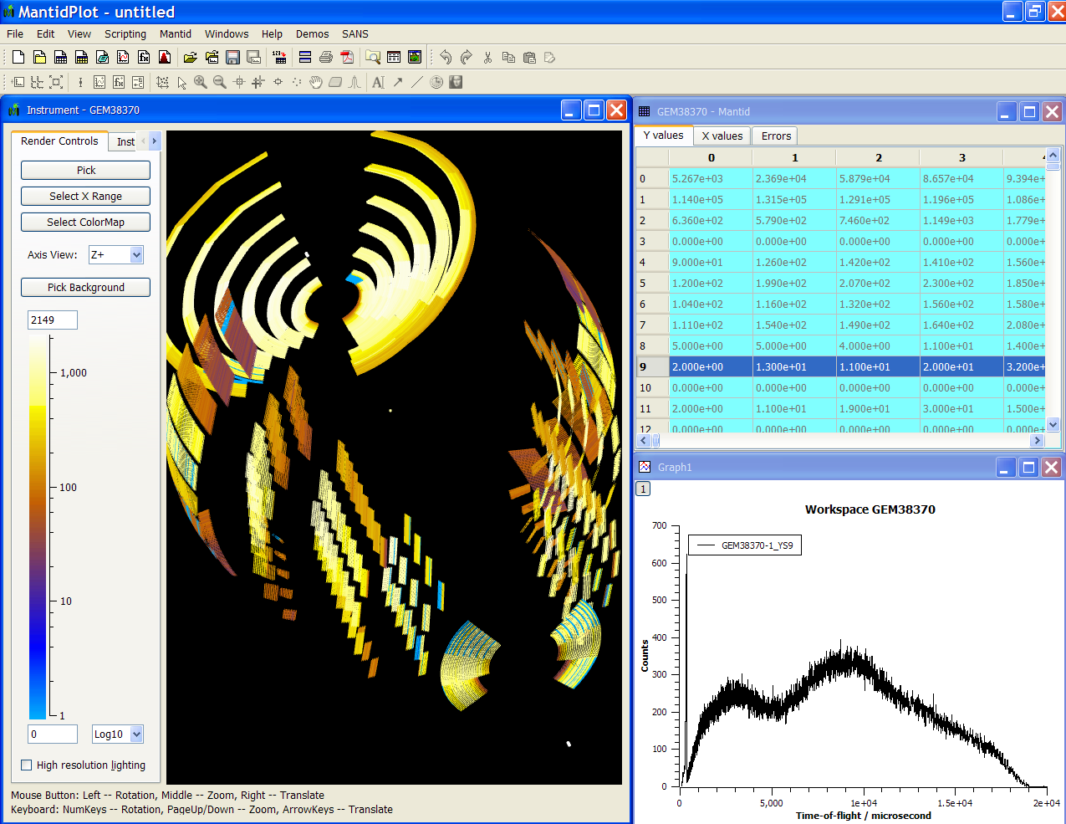
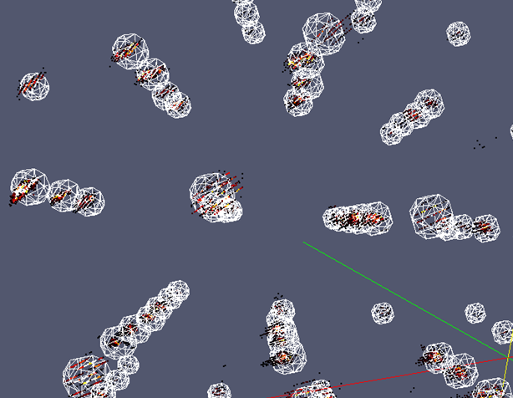
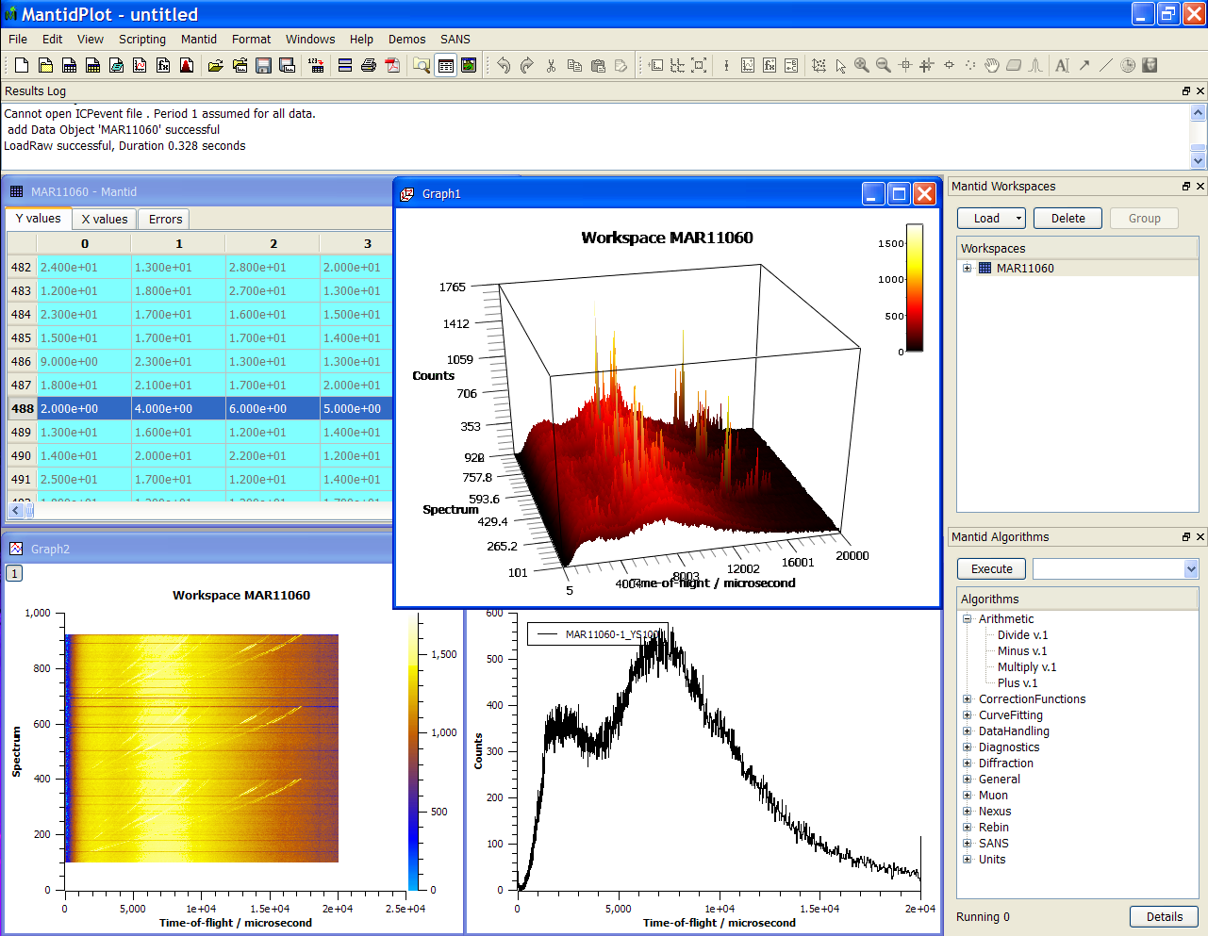
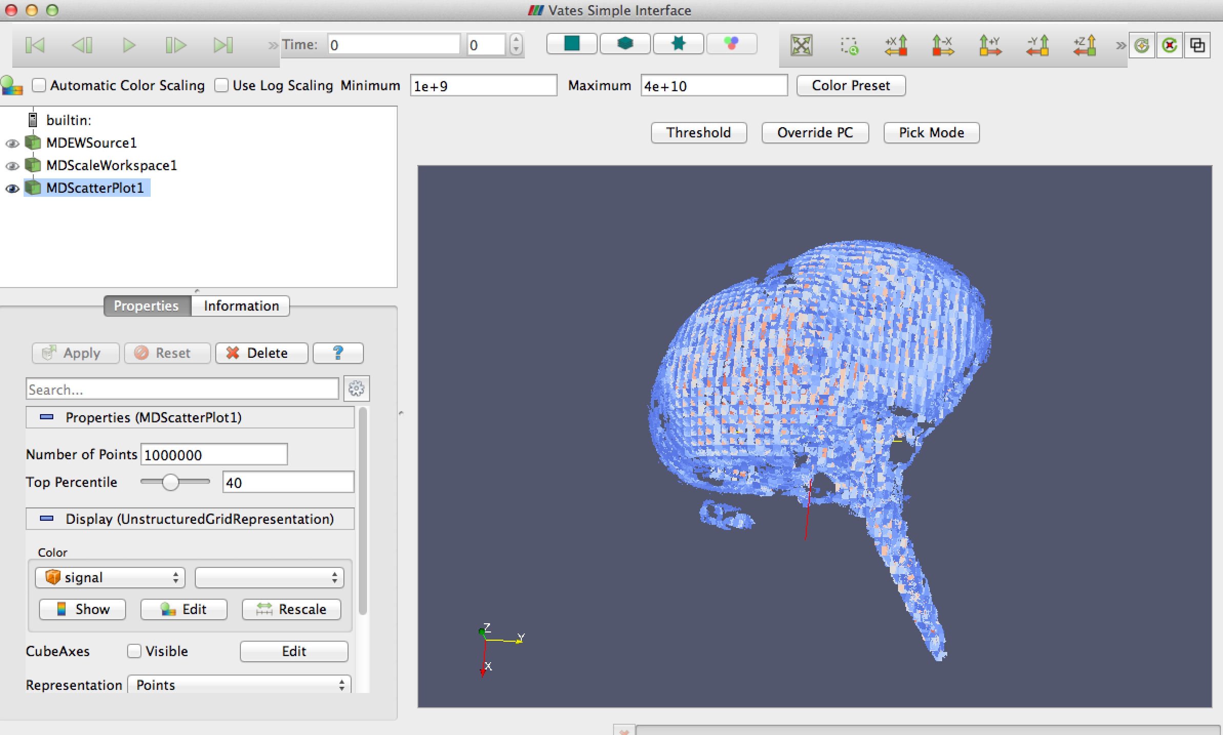
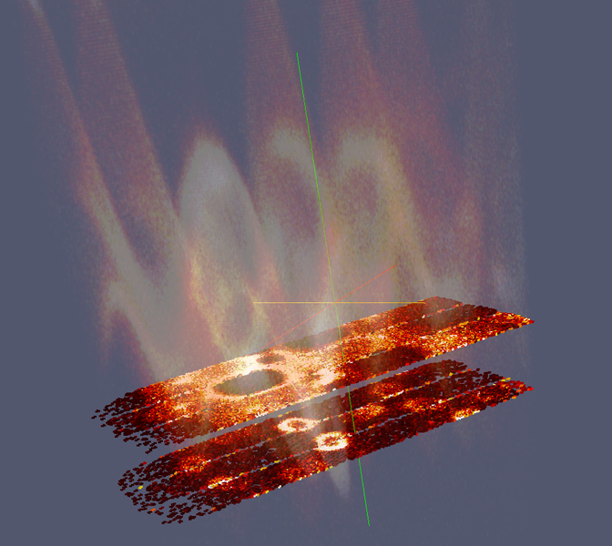
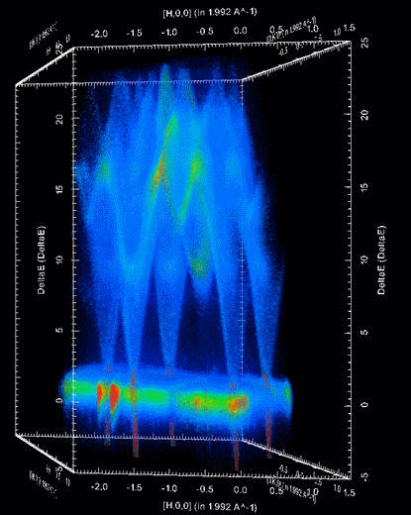

Document Control
This document is under document control. All members of the distribution list will receive updated copies whenever alterations are made. All other copies are uncontrolled.

Contributors
Name | Role | Company
Nicholas Draper | Author | Tessella

Document Approval
Name | Role | Company

Distribution
Name | Role | Company
Project Management Board Members | Recipient | Mantid Partnership
Mantid Project Repository | Filing | Mantid Partnership

Revision History
Author | Issue | Date | Description
Nicholas Draper | V1.R1.M0 | 1-Apr-2020 | 1st version written
Nicholas Draper | V1.R2.M0 | 2-Apr-2020 | Updated with Facility reports

References
Document | Ref | Date | Details and Version
Project Specification | [PS] |  | https://github.com/mantidproject/documents/blob/master/Project%20Management/ProjectSpecification.doc?raw=true
Stakeholder Plan | [SP] |  | https://github.com/mantidproject/documents/blob/master/Project%20Management/StakeholderPlan.doc?raw=true
Risk Register | [RR] |  | https://github.com/mantidproject/documents/blob/master/Project%20Management/RiskRegister.xls

Table of Contents
1 Introduction 3
2 Project Documentation 3
3 Project Status 4
4 Usage of Mantid in various Environments 8
5 Future Release Dates 11
6 Appendix A: Metrics 12

Introduction

Purpose of this Document
This report details the current state of the Mantid project. The project management board will use this report as an item for discussion at the meeting.

Scope of this Document
The scope of this document is limited to the Mantid project, both for progress up to the meeting of the Project management board and plans for the future.

Project Documentation
The project documentation is available through the links below:

Stakeholder Plan:
https://github.com/mantidproject/documents/blob/master/Project-Management/Stakeholder%20Map.doc?raw=true
Reviewed, Updated.

Risk Register:
https://github.com/mantidproject/documents/raw/master/Project-Management/RiskRegister.xls
Reviewed, Updated, added several risks associated with staff loss.

Project Status

Development Progress

Releases
Release 4.1
Released on time on the 23rd of July.
Highlights
- We have made significant improvements to support within the Mantid workbench for several techniques.
- adding several technique specific user interfaces ported over from Mantidplot.
- It also includes a fresh new implementation of the sliceviewer that merges in a lot of the popular functionality of the spectrum viewer into one capable tool.
- This version also introduces the new muon interface that is the result of a long effort to rebuild the interface using modern design and engineering standards, resulting in a much more stable, extensible interface, but also just so much better to use.
Release 4.2
Released on time on the 20th of November 2019
Highlights
- One of the major changes for this release is the new Direct ALF View GUI for aligning samples on the ALF Instrument.
- There have also been significant developments in the Indirect Interfaces:
  - The Analysis and Bayes Interfaces have been introduced to Mantid Workbench and all interfaces will accept lists to plot multiple spectra.
- Generally, usability has been improved, such as the cleaner ISIS SANS Interface and the multiple improvements in Workbench.
- The Script Repository has been added into Workbench
Release 5.0
Released on time on the 16th of March 2020
Highlights
- Mantid now runs Python 3
- We have fully migrated code in mantid and all scripts in the Mantid Script Repository Python 3 compatible.
- Other highlights include:
  - Waterfall Plots in Workbench
  - Settings menu in Workbench, with options to set your plot preferences, such as Marker Style and Error bar Capsize
  - Brand new Engineering Diffraction interface
  - Several performance improvements, in particular relating to scripts.
  - Redesign of the Muon Analysis and Frequency Domain Interfaces.

The next release 5.1 is planned for release on the 20th of July, with the following release plan:
- Code Freeze: 26th June
- Beta Test: 30th June -14th of July

The project metrics in Appendix A.

Mantid Workbench
We have made good progress with the Mantid workbench since the last PMB, but there is still work to do before it is ready to replace Mantidplot for all users. Version 4.1 saw most of the remaining Scientific Interfaces ported over to be included within the workbench, with release 4.2 including the remaining vital ones in order to be able to support a wide range of techniques. The most notable exception at the moment is Single crystal diffraction and any advanced usages of the sliceviewer which at present are only possible in Mantidplot.
Adoption of the workbench has been increasing and since Version 4.0 we have been able to track usage of workbench separately from Mantidplot, the graphs are available in Appendix A, but usage has been growing with each release, and with Version 5.0 we have almost 50% of users using workbench.
We have an umbrella issue that is tracking those features remaining to be implemented to allow migration from Mantidplot.
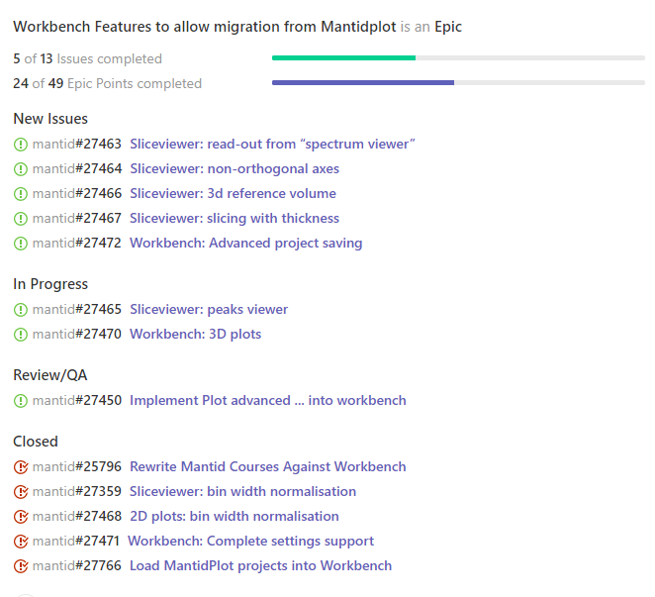
The majority of the issues remaining to resolve are within the sliceviewer, providing most of the more advanced usage of that tool. These are essential to various groups, any working with single crystals in particular. This is now the critical path in terms of being able to deprecate Mantidplot and be able to support all users on the workbench. The sliceviewer was initially allocated as a contribution to the workbench by the SNS, and they did indeed resource the development of the initial version that has been included since version 4.1 of the workbench. However, the focus on SANS software at the SNS has severely delayed the implementation of the remaining more advanced features. In order to make some progress on this critical path the ISIS team has started tackling some of this work, starting with the peaks viewer.

Mantidplot Deprecation
The workbench project was initiated to combat the risk that future operating systems would not support Qt4, and the associated plotting tools that we had originally been using for Mantidplot. At the time there were no immediate indications that this would occur, but the TSC have been monitoring the situation.
The next long-term support version of Ubuntu 20.04 will not support Qt4 based applications, and as a result we will not be able to deploy Mantidplot on this operating system. The Mantid framework, and mantid workbench will continue to work as normal, but for users of this operating system we now have a hard deadline, this is due for release on the 23rd of April, and we would normally pick it up as our supported version at the next major release of Mantid which would in this case be July.
At the present rate of development, we will not have all the remaining sliceviewer functionality included into workbench in time for the June code freeze for the July release. In addition, this does not allow sufficient time for instrument scientists to migrate to workbench, or any initial bugs to be resolved. Therefore, I suggest we consider the following options:
- Delay the support of Ubuntu 20.04 until the required development is complete.
- Support both Ubuntu 18.04, and Ubuntu 20.04, but only offer workbench with Ubuntu 20.04.
This approach will place further demands on the development team, testing, and further requirements for build servers.

Facility Team Updates

ISIS
Following the attrition to the team early in 2019 we were successful in recruiting several new staff:
- Harriet Brown – Junior Software Scientist, Total Scattering
- Daniel Murphy – Mantid Support and Testing
- Danny Hindson – Senior Software Scientist, Diffraction team lead
- Stephen Smith – Software Scientist, Muons
- Richard Waite – Junior Software Scientist, Single Crystal Diffraction
- Daniel Fairbrother – Graduate Developer, SANS
At the 2019 developer meeting we discussed the approach of moving to shorter ~month long development sprints to better follow agile development best practice. This was implemented at ISIS in August 2019, we have 3 development sprints per release followed by a release sprint. Each sub team holds separate sprint planning and review meetings together with daily stand up development meetings. The involved instrument scientists are included in the relevant sprint planning and review meetings to prioritise development and keep informed on progress and that is working well at the facility.
This change has improved communication between the development teams at ISIS and between the ISIS developers and the instrument scientists, but we have become aware it has tended to make the team more insular, and communication has decreased with our international collaborators, although this has also coincided with a period where each of the international teams have been less involved with Mantid development for various reasons. We have reintroduced a monthly cross team planning meeting after the sprint planning meetings where each team lead will share a progress update and their plans for the next sprint with both the local and remote teams, and we are experimenting with recording this meeting for anyone that cannot attend to watch.

ILL
Mantid is fully adopted for direct and indirect geometry spectrometers: IN4, IN5, IN6, PANTHER and IN16B (including Doppler and BATS modes). It is also operational but only partially adopted by powder diffraction instruments D2B and D20. Extensive tests have been performed by the scientists on D2B confirming that Mantid reduction is correct. However, this took few iterations since the original results were not great, but, as it turned out, this was only due to wrong geometry calibration, which was derived outside Mantid. The reduction backends are developed for SANS (D11, D16, D22, D33) and Reflectometry (D17, FIGARO), but the work on the GUI, which is indispensable for LSS audience, has started only recently. A major challenge for reflectometry was to keep up with the nexus file structure that was in active development itself.
The phase 2 of the Bastille project has started with 3 developers on 3-year contracts. Along with the development for the suite of the other 10-15 instruments, phase 2 will need to focus also on graphical tools in order to finalize the adoption for SANS and Reflectometry. The graphical functionality comprises several aspects: a spreadsheet based interface, of which we have a prototype already, series of extensions in the instrument viewer, and a new Raw Data Explorer widget in the workbench, that will facilitate the visualization of raw data. Regarding the spreadsheet GUI, a satellite project which is the auto-generation of the tables, needs to be developed, which is a challenge itself, since there is little rigor in metadata tagging by the users. Other auxiliary projects include engine for automatic reduction, for which we have a working version, and ability to treat event data, for which first task would be to change the file format from ILL event list binary to the standard event nexus.
The principal challenge was the gap between the phase 1 (ended April 2019) and the commencement of the phase 2 (starting now) which imposed a problem of knowledge transfer. This was the most severe for Reflectometry, when the expert developer left without having handed over to the scientists.

SNS
In February of 2020 the group containing the ORNL developers involved in mantid were merged into the Research Software Engineering Group (RSE) of Computer Science and Mathematics Division (CSMD). Neutron Scattering Directorate (NSD) has not modified its spending or commitment to the mantid collaboration. This shift allows for use of a broader set of skills in the RSE group and increased engagement with other groups in CSMD.
Construction of the proton power upgrade (PPU) to double the power of the linac of SNS to 2.8MW have begun and the second target station (STS) project office has formed and is in a hiring mode. The STS is now working on detailed designs of the facilities and the first round of instruments.
The focus of the past several months for ORNL effort has been on reduction of SANS data with a unified software which is heavily based on mantid. The SANS work has slowed down our migration of dependent scripts to python3 which is a requirement of mantid 5.0.
With the work on SANS winding down, RSE has been moving towards improved performance of loading Event NeXus files and is preparing the first round of changes which preliminary results show 25-35% faster performance. Once that is done, we are designing new options for improving this further including options that aren’t entirely limited to LoadEventNexus and exploit instrument specific data patterns.

ESS
Mantid was successfully used for transition to operations milestones for the ESS 2019-2020. There were two major work streams here. Firstly, for LOKI, live data reduction performance milestones, aimed at achieving at 10^8 event/s ingest and reduction rate which would be required for full-power operation. This was achieved in collaboration with the DMSC Data Management group and wider Data Analysis team for the ESS. The subsequent transition to operations document has been verified and uploaded to ESS Chess. The second work stream relates to experimental support for the V20 ESS Test Instrument, where Mantid was used to reduce data live, and post-collection, for a wide range of different experimental setups using analogous beam characteristics and chopper configurations to the real ESS instrument configurations. A number of scientific papers are in draft based on the results. The ESS contributed Nexus Geometry support, and the read capabilities for this have been fully integrated, honed and optimised. The is now also support for basic serialisation to the Nexus Geometry format directly from Mantid Instruments.
During 2020, The ESS have contributed to the CI setup and conda based build and packaging for Mantid. We have also provided on-going support to ESS V20 and LOKI beamline scientists. We have provided a number of generic python extensions and library level fixes.
Scipp is a major focus for the ESS team in 2020 with particular attention on the ODIN imaging beamline.

CSNS
The CSNS have now formally joined the collaboration. We had been planning a workshop at the CSNS to kick off the collaboration and introduce many of the development team leads in the project to the CSNS team. Unfortunately, the COVID-19 outbreak meant that we had to cancel the workshop, and shortly after the CSNS team, followed by everyone else had to move to work from home to limit spread of the virus.
The CSNS team have now returned to the CSNS site and we have started a programme of teleconferences to progress the collaboration, although these are only at an early stage at the moment. Here’s a presentation that shows some of what they have developed and deployed using Mantid thus far. We are working with them to merge in some of there algorithms for loading their file formats and we have meetings planned to introduce them to our developments in Engineering and Imaging.

Usage of Mantid in various Environments
We currently fully support the following environments:
- RHEL 7 64bit
- Windows 10 64 bit
- Ubuntu 18.04 64 bit
- OS X 10.13+
Questions:
- RHEL 8 has now been released, is there any timescales for the different facilities to adopt this?

Current Usage:
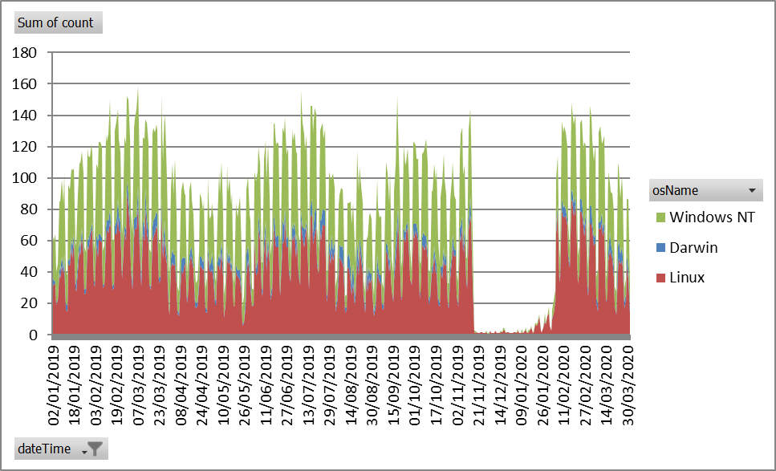

This is the number of distinct users each day, separated by the operating system they use.
We had a server problem that prevented recording of usage data between November 2019 and January 2020. These numbers will not include usage from auto reduction services.
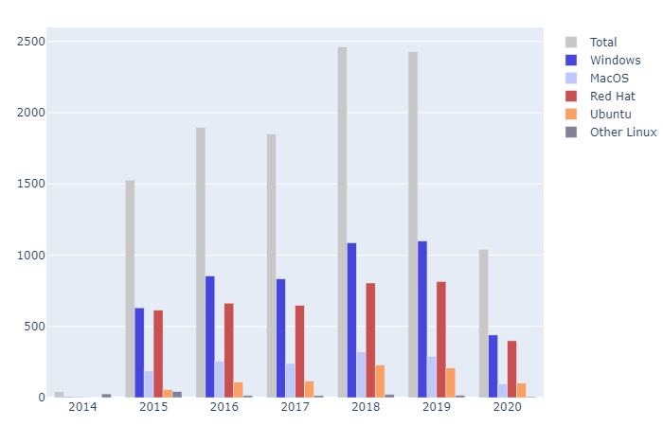This graph shows the unique user count per year, the 2020 numbers are for the year so far. The numbers for 2019 and 2020 will have been reduced by the missing data mentioned earlier.

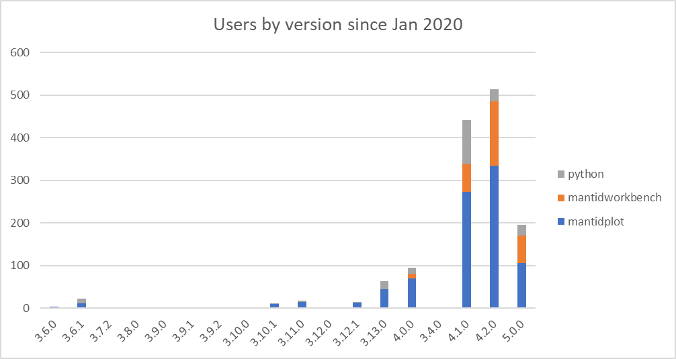

This is a view of the number of users that have used differenct versions of Mantid since January 2020. Mantid 5.0 was only released for the last few weeks of this period, but has already picked up a good volume of users.
We have a significant tail of old versions, this is not a problem per se as long of the users of those versions do not need active support. Given the approach of visiting scientists leaving with a locally installed version then this is to be expected as they are unlikely to upgrade from the version that works for them.

Error Reporting
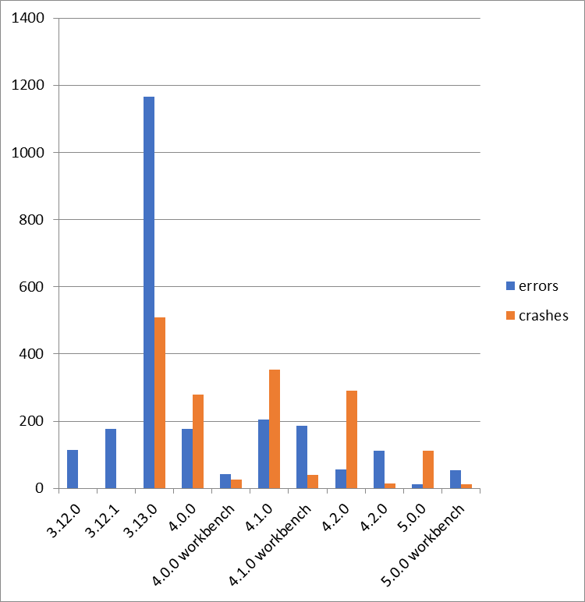
This graph shows both the raw numbers or errors and crashes sent through error reporting for each version. As version 5.0.0 has only been released recently we would expect the counts for that to continue to increase For the sake of this graph they are defined as:
- Errors – Problems that caused the ast chance error dialog within Mantidplot to appear.
- Crashes – Problems where Mantidplot exited impropoerly, this can include situations where it is terminated because it has hung.
Crash reporting was only introduced in release 3.13.0, so these occaisions went unreported in previous versions

Future Release Dates
Planned dates:
- V5.1 20th July 2020
- V5.2 2nd November 2020

The first version not to include Mantidplot for any operating system will be renamed as version 6.0.

Appendix A: Metrics

Project Metrics
The code metrics are independently generated and displayed here
http://www.openhub.net/p/Mantid/analyses/latest/languages_summary

Total Lines : | 2,513,619 |  | Code Lines : | 1,801,311 |  | Percent Code Lines : | 71.7%
Number of Languages : | 17 |  | Total Comment Lines : | 394,510 |  | Percent Comment Lines : | 15.7%
 |  |  | Total Blank Lines : | 317,798 |  | Percent Blank Lines : | 12.6%

Code, Comments and Blank Lines
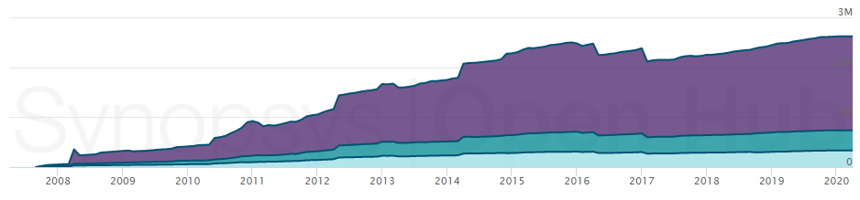
Code
Comments
Blanks

In a Nutshell, Mantid...
- has had 112,239 commits made by 199 contributors representing 1,883,250 lines of code
- is mostly written in C++ with an average number of source code comments
- has a well established, mature codebase maintained by a very large development team with decreasing Y-O-Y commits
- took an estimated 541 years of effort (COCOMO model) starting with its first commit in April, 2007

